Beyond the PC
Paradigm Shifts for Job Seekers
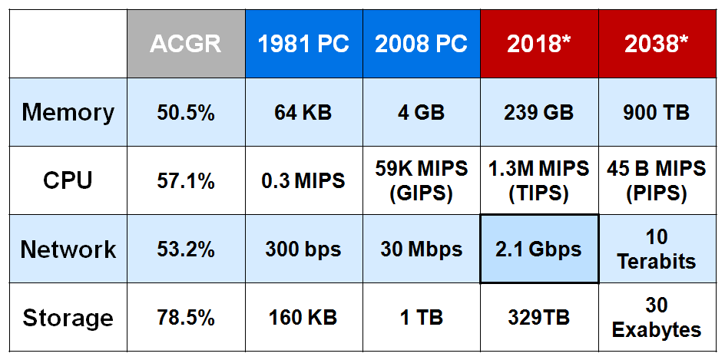
Wayne Caswell is a technologist, futurist and marketer with IBM, Dell, Siemens and his own consulting firm. With over 40 years of tech experience, Wayne knows the positive effect digital technologies can have on society and the challenges of adopting them.

Wayne started his career at IBM, moving from computer operations through programming, systems programming and systems engineering before helping to launch the IBM PC and shifting focus from an enterprise technology solutions to consumer marketing, planning and strategy.

Wayne most recently left Homeowners of Texas, a nonprofit consumer advocacy that he co-founded and where he served for two years as Communications Director. HOT, in its first year and with no funding, took on powerful lobbyists of the $35 Billion Texas Homebuilding industry and won. Wayne was instrumental in convincing lawmakers to establish new consumer protection laws and abolish an abusive state agency, the Residential Construction Commission. He's now exploring new business ventures and career options in high-growth and high-impact market sectors like Broadband & Wireless Internet, Web 2.0 & Cloud Computing, and Digital Home technologies for Elder Care, Energy Management, and Entertainment.

See http://www.waynecaswell.com for a more detailed BIO with links to his presentation slides, speaker notes, resume, and portfolio.
Paradigm Shifts:
- From Mainframe (expensive, shared) to PC (affordable, personal)
- From Stationary (desktop PC) to Mobile (notebooks, iPhone)
- Machine-to-machine (embedded computing, communications, power)
- Converged Disciplines (info, bio, nano, socio)
Key Points:
- The Future ain’t what it used to be, but is coming Faster, Fiercer.
- Today’s learner will have 10-14 jobs by age 38.
- 25% of workers have been at their employer for less than one year.
- >50% have worked there for less than five years.
- The top 10 “in demand” jobs in 2010 didn’t exist in 2004.
- The U.S. has lost its Broadband and Tech leadership.
- >100M MySpace users with average 30 visits per day each.
- 160 Exabytes of info generated WW is more than in previous 5K years.
- Tech info is doubling every 2 years now; will double in 72 hrs by 2010.
- By 2023, a $1000 computer will compare to the human brain.
- By 2037, a $0.01 computer will.
- By 2049, a $1000 computer will compare to the human race.
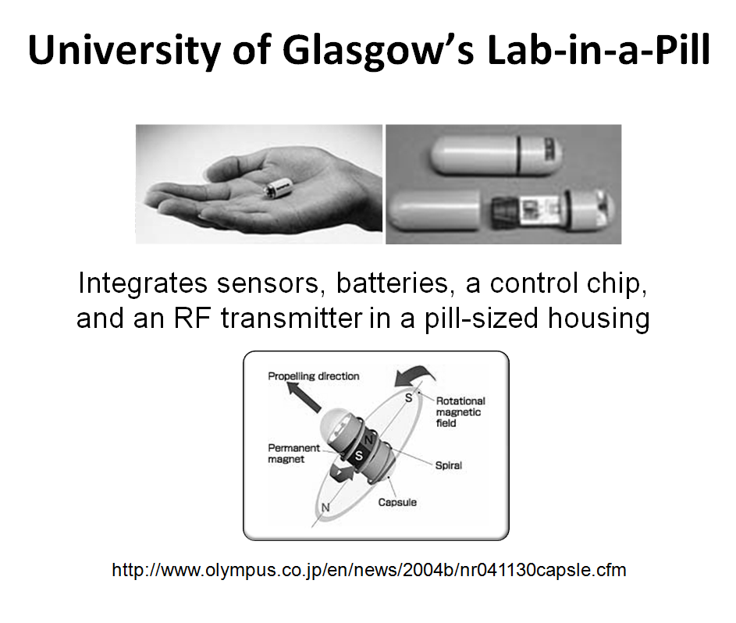
- By 2059, a $0.01 computer will.
Implications:
- Work for Yourself while working for Others
  - It’s YOUR Financial Planning & Retirement
  - It’s YOUR Healthcare, and Your Family’s
  - It’s YOUR Personal Development
- The Retooling Dilemma
  - Rising Education Costs
  - Shorter Careers to Justify them
  - Flattening Org Chart, eliminating Mid-Layers
- Freelancing / Consulting
- Starting a Business / Partnering / Franchising

